Predictive Maintenance for Automobiles using IOT And Machine Learning

**Laxman M N** 1 **Keerthan C K 2 Anand S.S3 Tarun K.H4 Under the Guidance of Mr. Jagadish M**

**Department of Electronics & Communication**

**Acharya Institute of Technology, Bangalore – 560107**

[keerthan777@proton.me](mailto:keerthan777@proton.me)

***Abstract:* The complexity and hazards of autonomous vehicle systems have posed a significant challenge in vehicle maintenance. An automotive system is important for the reduction of surprise failures, reduction of downtime, and improvement in vehicle performance. There is a need for a IoT-based predictive maintenance solution for key components of vehicles, where the information from sensors in real-time about the status of temperature, vibration, battery conditions, among other parameters, can predict failures with necessary time and action for maintenance based on machine learning algorithms and data analytics. This project uses the advances in the related technologies of autonomous vehicle PDM and machine learning algorithm to address the inadequacies of current maintenance methods by developing a proactive solution for safe, cost-effective, and overall reliability of the vehicle. The expected output will be a real-time dashboard, an alert system, and validated predictive algorithms that hugely improve vehicle performance and operational cost.**

# INTRODUCTION

Predictive maintenance (PDM) has transformed the automotive industry, shifting from reactive problem-solving to a proactive approach that emphasizes precision. With machine learning, PDM can

forecast when a machine or vehicle component is likely to fail. [1] It analyses historical data and interprets real-time signals to anticipate breakdowns before they occur. From monitoring vibration patterns and oil quality to assessing thermal signatures and equipment performance, PDM turns raw data into useful insights. In the high-pressure environment of automotive manufacturing, where even a brief period of downtime can lead to significant losses, [2] PDM helps ensure that machines remain reliable, operations run smoothly, and costs are managed effectively. Maintenance evolves from a reactive and often disruptive task to a streamlined and efficient process, demonstrating how technology can proactively enhance reliability and drive progress.

Traditional vehicle maintenance methods, such as periodic maintenance and reactive repairs, often lead to unnecessary part replacements, unexpected breakdowns, and high operational costs for vehicle owners. This project focuses on implementing PDM for automotive systems using IoT. By Utilizing sensor data and real-time monitoring, the system predicts potential failures, reducing downtime and maintenance costs, while improving vehicle reliability and safety. [3]

The IoT enables seamless connectivity between the vehicle’s onboard sensors and ML model. This connected network allows the collection and checking data such as engine temperature, fuel levels, tire

pressure, and battery health. By continuously monitoring parameters such as temperature, vibration, oil level, battery performance, and gas levels, the system identifies potential failures before they occur. The integration of an ESP32 microcontroller with a Python Flask-based server enables real-time data processing, anomaly detection, and user-friendly dashboard visualization. [4]

Problem Statement

Traditional vehicle maintenance methods are inefficient, leading to unnecessary component replacements, high operational costs, unplanned downtime.

Modern vehicles lack real-time monitoring and predictive capabilities for critical components like the engine, battery, and brakes. This results in difficulty in identifying potential failures early, suboptimal performance and reliability. [5]

Objectives

Develop a real-time vehicle monitoring system using ESP32 and various sensors. Predict vehicle maintenance requirements using machine learning algorithms. Send alerts to vehicle owners via Telegram messages for proactive maintenance. Detect accidents and other critical issues such as overheating, low oil levels, and poor battery health. [6] Ensure wireless communication of sensor data to a central laptop for analysis and storage.

Why do we need ML Algorithm: In PDM for automobiles, the Random Forest tree algorithm is essential for predicting potential failures and maintenance needs based on sensor data. This ensemble learning approach makes several decision trees, each trained on a random subset in the provided data. [7]The final prediction is made by combining the outputs from all trees, using the mode for classification or the average for regression. Random Forest is particularly effective at dealing with noisy data and complex relationships, making it an excellent choice for PDM,

where sensor data can vary due to environmental conditions or wear and tear on components. [8] Additionally, it’s useful for estimating the Remaining Useful Life (RUL) of parts. [9]By training on a labelled dataset that includes historical sensor data and maintenance records, the system is capable of generating accurate predictions about the health of vehicle components.

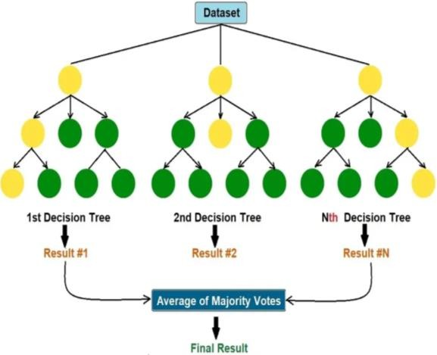

*Figure 1: Tree Diagram of Machine Learning Model*

# METHODOLOGY

IoT sensors are assigned for keeping track of the condition of car parts in real-time. Various sensors, such as those measuring vibration, temperature, and pressure, along with other specialized devices, are used to identify wear and tear in important vehicle components. [10]

Data Transmission & Web Interface: The information collected from the sensors is transmitted to a central server for processing. Communication protocols such as MQTT or HTTP are used to send sensor data to either a cloud or local server, where it undergoes further analysis. A user- friendly web interface is designed to display real-time data, alerts, and maintenance predictions to users. This interface allows users to interact with the system, input data, view predictive maintenance results, and receive notifications about necessary maintenance tasks. [11]

Machine Learning Model: The predictive maintenance system utilizes a machine learning model to analyze sensor data and proactively predict potential failures or maintenance requirements. The Random Forest algorithm is employed for this purpose, leveraging an ensemble learning approach. In the initial phase, multiple decision trees are generated, with each tree trained on a random subset of data through bootstrapping. At each decision point, a random selection of features is assessed. The final output is determined by selecting the most common class for classification tasks or calculating the average prediction for regression tasks. This method helps reduce overfitting and enhances the model’s ability to generalize. By analyzing historical data, the model can identify patterns that indicate possible equipment failures, allowing for proactive maintenance actions. [12]

Alert Mechanism: In the predictive maintenance system, multiple sensor modules are utilized to deliver timely and effective notifications. When the machine learning model identifies a fault or anomaly, the system triggers alerts through three primary channels: an LCD display, a buzzer, and a Telegram bot. The LCD display provides real-time visual alerts on the vehicle's dashboard or in the maintenance area, showing messages like “Engine Overheating” or “Vibration Anomaly Detected.” Simultaneously, the buzzer emits an audible alarm to quickly grab the attention of the driver or mechanic. Additionally, the Telegram bot sends personalized notifications to the user or maintenance team, facilitating monitoring and interaction. These alerts ensure that potential issues are addressed promptly, reducing the risk of unexpected breakdowns and extending the vehicle's lifespan. [13]

The components and their functions are detailed below:

1. Sensor Module: This module gathers real-time data from different parts of the vehicle:

DHT11 (Temperature Sensor): Monitors the ambient temperature. Vibration Sensor (SW420): Detects unusual vibrations that could signal faults. Ultrasonic Sensor (HC- SR04): Measures the oil level to identify shortages. Fuel Vapours Sensor (MQ3): Detects fuel vapor leaks. Motion/Shock Sensor (ADXL345): Monitors shocks or jerks that may indicate physical impacts or system problems.

1. Battery Management System (BMS)

The BMS maintains the health of the vehicle’s power supply by monitoring: Temperature Sensor (DS18B20): Measures the battery’s temperature to detect overheating. Voltage Sensor: Keeps track of the battery voltage to ensure it operates correctly. Current Sensor: Monitors current usage to identify overloading or abnormal draw.

1. ESP32 Microcontroller

The ESP32 acts as the central controller: Collects data from the sensors and the BMS. Displays essential information on the LCD Screen (16x2) for the driver. Activates the Buzzer Alert when an anomaly is detected. Sends data to the Zigbee Module for wireless transmission.

1. Zigbee Module

This module facilitates wireless

communication: Transmits the collected sensor data from the ESP32 to the back- end system for further analysis.

1. Back-End System

This system processes and analyzes the transmitted data: Machine Learning Model: Identifies patterns and predicts potential failures. Flags anomalies based on historical and real-time data. Database: Stores sensor data, predictions, and historical data for analysis and enhancing ML model.

1. Dashboard (Front-End): A GUI for user to monitor real-time data, alerts, and historical trends. It provides actionable insights to the user or maintenance team.
2. Alerts and Notifications: Buzzer Alert: Provides immediate audio feedback to the driver when critical issues arise. Telegram Bot: Delivers notifications with detailed

information to remote users or maintenance teams, enabling proactive responses. [14]

1. Power Supply (PSU)

The system operates on a Lead Acid Battery,

guaranteeing dependable functionality for all components.

# BLOCK DIAGRAM AND FLOW CHART

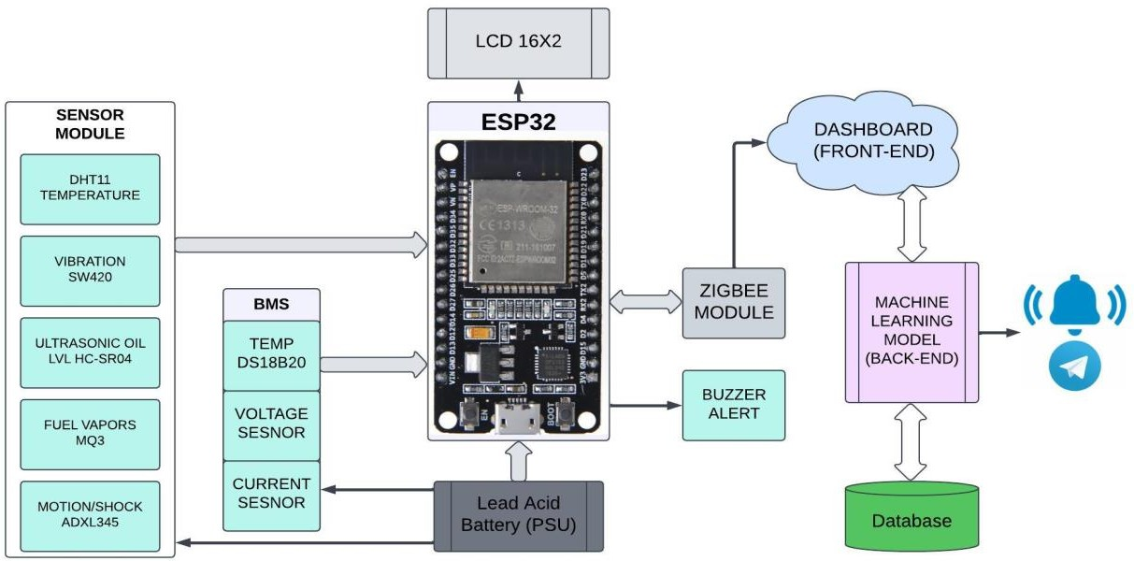

*Figure 2 : Block Diagram*

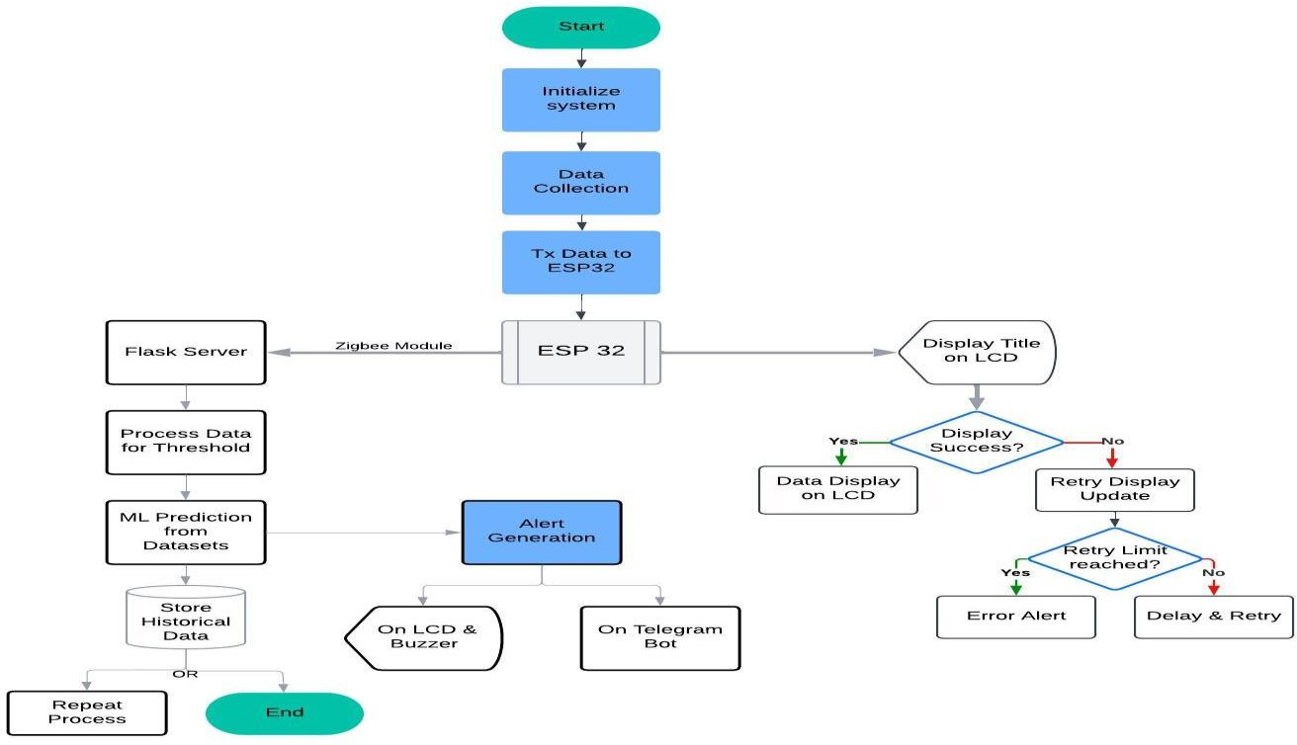

*Figure 1: Flow Diagram*

Telegram Bot Notification:

Integrating a Telegram bot into the Predictive Maintenance System for Automobiles starts with the creation and setup of the bot. This is done using Bot Father on the Telegram app, where a new bot is created, and a unique Bot Token is generated to authenticate and interact with the Telegram API.

This data is processed by the ESP32 microcontroller, which sends the information to the back-end server using Zigbee or other communication protocols. The back-end server analyzes the incoming sensor data through threshold checks and machine learning models to detect potential faults or anomalies, such as high engine temperature, unusual vibrations, or low oil levels. When an issue is identified, an alert is generated.

The bot also facilitates two-way communication, enabling users to interact with the system. Users can issue commands like /status to get real-time sensor data or

/history to access historical trends and logs. These commands are handled by the back- end, which returns the requested data to the user via the bot.

## Advantages:

Proactive Problem Solving: Identifies issues early on to avoid expensive and inconvenient vehicle breakdowns.

Economic Benefits: Helps save money by minimizing unnecessary repairs and streamlining maintenance schedules.

Safety First: Safeguards users by alerting them to critical issues like overheating and potential accidents before they worsen.

Real-Time Monitoring: Zigbee-powered data transmission provides instant diagnostics, regardless of the vehicle's location.

Versatile Applications: Functions smoothly for personal cars, commercial fleets, and industrial vehicles alike.

Eco-Friendly Approach: Reduces waste by extending component lifespan and decreasing unwanted replacements.

## Disadvantages:

Upfront Investment: The initial investment for sensors and infrastructure may put off potential users.

Connectivity Challenges: A reliable network connection is necessary, which may not be accessible in certain regions.

Technical Expertise Needed: The installation and maintenance processes require specialized knowledge in IoT and machine learning.

Component Maintenance: Sensors and systems need regular inspections, contributing to ongoing maintenance efforts.

## Future scope and

**enhancement**

Smarter Models with Deep Learning Utilize LSTM networks to effectively analyze time-series data, enhancing the accuracy of anomaly predictions. Employ CNNs for recognizing spatial patterns, which improves the classification of faults in sensor readings. Incorporate adaptive learning features that enable the system to refine its predictions in real-time as it gathers more data.

Cloud intelligence to enhance scalability by shifting data processing and visualization to cloud platforms such as AWS, IoT Core, or Google Cloud IoT. This transition boosts computational power and scalability. Provide real-time global insights with advanced dashboards accessible from any device.

Expanding the Sensor Ecosystem Install sensors in vehicles to monitor tire pressure, fuel efficiency, and emissions, turning the system into a comprehensive maintenance solution. Choose weather-resistant and durable sensors to guarantee dependable performance in harsh weather conditions.

Mobile-First User Experience Create a user-friendly mobile app that enhances Telegram notifications with in-depth diagnostics, predictive reports, and service reminders. Allow for remote control and real-time updates, giving users the ability to manage their vehicle's health right from their devices.

Predictive Maintenance as a Subscription Transform the solution into a Predictive Maintenance as a Service (PMaaS) model, providing customized plans for both individual users and fleet operators. Incorporate premium features such as personalized analytics, tiered subscription options, and automated maintenance scheduling.

Fortified Data Privacy and Security Adopt strong encryption methods to protect user data during both transmission and storage. Ensure to build user trust and maintain data integrity.

Green Driving for a Sustainable Future Add features that track and minimize emissions, supporting environmental sustainability. Offer practical insights for eco-friendly driving, enhancing efficiency while lowering carbon footprints.

1. **CONCLUSION**

This project successfully developed a comprehensive Predictive Maintenance System for automobiles, integrating real- time monitoring, advanced analytics, and a user-friendly design. By continuously tracking essential parameters such as temperature, vibrations, battery health, oil levels, and gas presence, the system enabled early detection of anomalies with accurate thresholds. Utilizing the Random Forest algorithm, it effectively predicted maintenance requirements, including estimating the Remaining Useful Life (RUL) of various components. This proactive strategy reduced risks like overheating or low battery levels while allowing users to plan maintenance more effectively. The incorporation of an intuitive Telegram bot provided instant

alerts and enabled users to engage with real- time data and performance trends. The solid architecture, driven by the ESP32 microcontroller and Zigbee communication, facilitated dependable sensor data management and user access through an LCD interface. Improved safety measures, such as accident detection and vibration-triggered alerts, enhanced emergency responses and lowered breakdown risks. Thorough validation of machine learning models and sensor readings ensured high accuracy in practical applications. The addition of an informative dashboard further streamlined decision- making by displaying actionable alerts and health trends. Overall, the system emerged as a transformative solution for enhancing vehicle safety, reliability, and cost efficiency, setting the stage for smarter automotive maintenance strategies.

**References**

|  |  |
| --- | --- |
| [1] | F. Arena, M. Collotta, L. Luca, M. Ruggieri  and F. Termine, Predictive Maintenance in the Automotive Sector, 2021:  Mathematical and Computational Applications MDPI. |
| [2] | A. a. A. S. Kanawaday, Machine learning for predictive maintenance of industrial machines using IoT sensor data, IEEE, 2017. |
| [3] | C. L. Y. S. X. C.-G. D. T. S. Chen,  Automobile maintenance modelling using gcForest, IEEE, 2020. |
| [4] | M. M. A. G. a. S. M. Cakir, The  experimental application of popular machine learning algorithms on  predictive maintenance and the design of IIoT based condition monitoring system., Computers & Industrial  Engineering 151, 2021. |

|  |  |
| --- | --- |
| [5] | M. A. M. D. A. V. P. N. K. J. L. K. G,  Predictive Maintenance of Motors using Machine Learning, Kumaraguru College, Issue 4, 2024. |
| [6] | V. S. Rohit Dhall, An IoT Based Predictive Connected Car Maintenance Approach, International Journal of Interactive Multimedia and Artificial Intelligence, 2022. |
| [7] | R. e. a. Jiang, Predictive maintenance of autonomous vehicles using machine learning and IoT, Sustainable Computing: Informatics and Systems, 2021. |
| [8] | C. L. Y. W. S. S. X. D. C.-G. C. T. S. a. S.  Chen, Predictive maintenance using cox proportional hazard deep learning, Advanced Engineering Informatics, 2020. |
| [9] | S. a. K. A. Yvaz, Predictive maintenance system for production lines in  manufacturing: A machine learning approach using IoT data in real-time, Expert Systems with Applications 173, 2021. |
| [10] | A. K. S. A. P. N. &. S. V. Kalusivalingam, Enhancing Predictive Maintenance in Manufacturing Using Machine Learning Algorithms and IoT-Driven Data  Analytics, International Journal of AI and ML, 2020. |
| [11] | Y. L. H. &. T. X. Zhang, Machine learning in autonomous vehicles, IEEE, 2020. |
| [12] | C. V. S. M. D. S. R. Aravind, Machine Learning Applications in Predictive Maintenance for vehicles, International Journal Of Engineering And Computer Science, 2022. |
| [13] | A. M. A. S. A. E.-E. Sherien N. Elkateb,  Machine learning & IoT – Based  predictive maintenance approach for industrial applications., Alexandria  Engineering Journal, 2024. |

|  |  |
| --- | --- |
| [14] | S. S. M. G. A. P. Gerasimos G. Samatas,  Predictive Maintenance – Bridging Artificial, IEEE, 2021. |
| [15] | yvaz, Serkan, and Koray Alpay.  "Predictive maintenance system for production lines in manufacturing: A machine learning approach using IoT data in real-time.", Expert Systems with Applications 173 (2021): 114598.. |
| [16] | Machine learning & IoT – Based  predictive maintenance approach for  industrial applications. |

The Report is Generated by DrillBit Plagiarism Detection Software



***Submission Information***

|  |  |
| --- | --- |
| Author Name | Keerthan C K |
| Title | PAPER |
| Paper/Submission ID | 2934274 |
| Submitted by | [asklibrarian@acharya.ac.in](mailto:asklibrarian@acharya.ac.in) |
| Submission Date | 2025-01-03 11:12:30 |
| Total Pages, Total Words | 7, 2603 |
| Document type | Project Work |

***Result Information***

Similarity **9 %**

|  |  |  |  |  |  |  |  |  |  |
| --- | --- | --- | --- | --- | --- | --- | --- | --- | --- |
|  | | | | | | | |  |  |
| 1 | 10 | 20 | 30 | 40 | 50 | 60 | 70 | 80 | 90 |
|  |  |  |  |  |  |  |  |  |  |

Sources Type Report Content

|  |  |  |
| --- | --- | --- |
|  | | Internet 4.03% |
| Journal/ |  |
| Publicatio |
|  |
| n 4.97% |
|  | |

Quotes 0.85%

Words < 14,

3.34%

***Exclude Information Database Selection***

|  |  |  |  |
| --- | --- | --- | --- |
| Quotes | Excluded | Language | English |
| References/Bibliography | Excluded | Student Papers | Yes |
| Source: Excluded < 14 Words | Not Excluded | Journals & publishers | Yes |
| Excluded Source | **0 %** | Internet or Web | Yes |
| Excluded Phrases Not Excluded | | Institution Repository | Yes |

A Unique QR Code use to View/Download/Share Pdf File



**DrillBit Similarity Report**

**9 12 A**

**A-Satisfactory (0-10%)**

**B-Upgrade (11-40%)**

**C-Poor (41-60%)**

**D-Unacceptable (61-100%)**

SIMILARITY % MATCHED SOURCES GRADE

**LOCATION MATCHED DOMAIN % SOURCE TYPE**

**1** [jeeeccs.net](https://jeeeccs.net/index.php/journal/article/viewFile/327/247) 2 Publication

**2** [orca.cardiff.ac.uk](https://orca.cardiff.ac.uk/id/eprint/137968/1/2021ChenCPhD.pdf) 2 Publication

**3** [mdpi.com](https://www.mdpi.com/2075-1702/11/2/191/htm) 1 Internet Data

**4** [www.mdpi.com](https://www.mdpi.com/2076-3417/11/12/5725) 1 Internet Data

**5** [ein.org.pl](https://ein.org.pl/Short-and-long-forecast-to-implement-predictive-maintenance-in-a-pulp-industry%2C158465%2C0%2C2.html) 1 Internet Data

**6** [ebin.pub](https://ebin.pub/evolutionary-computing-and-mobile-sustainable-networks-proceedings-of-icecmsn-2020-1st-ed-9789811552571-9789811552588.html) 1 Internet Data

**7** [huggingface.co](https://huggingface.co/datasets/pszemraj/fleece2instructions/resolve/main/train.csv) 1 Internet Data

**8** [docplayer.net](http://docplayer.net/15572085-Operational-plan-document-for-2014-16-bradford-teaching-hospitals-nhs-foundation-trust.html) <1 Internet Data

**9** [The next evolution of MDE a seamless integration of machine learning](https://dx.doi.org/10.1007/s10270-017-0600-2) [by Hartmann-2017](https://dx.doi.org/10.1007/s10270-017-0600-2)

**10** [Learning Personalized Discretionary Lane-Change Initiation for Fully](https://dx.doi.org/10.1109/smc42975.2020.9283222) [Autonomous by Liu-2020](https://dx.doi.org/10.1109/smc42975.2020.9283222)

<1 Publication

<1 Publication

**11** [www.ijsrd.com](http://www.ijsrd.com/articles/IJSRDV5I10274.pdf) <1 Publication

**12** [www.dx.doi.org](https://dx.doi.org/10.1016/j.eswa.2021.114686) <1 Publication